Jacked

The Shadowrun Tower Defense Game

Table of Contents

Introduction 2

Overview: 2

Story: 2

Game Play: 2

Controls: 2

Features: 2

Programs: 2

ICE: 2

Persona: 2

Deck: 2

Missions: 3

Game Play 3

Rules: 3

Modes: 3

Interface Design: 3

Layout: 3

Programming Design: 3

Objects and Sprites: 3

Artificial Intelligence: 3

Music and Audio: 5

Music Description: 5

Sound Effects: 5

Scenarios: 5

Concept Art: 6

Concept Art (Cont’d): 7

Concept Art (Cont’d): 8

Appendix A: 9

Appendix B: 10

# Introduction

## Overview:

The player selects their load out of attack and defense programs and uses them to protect their persona while trying to break into various data servers to extract the data they were hired to take.

## Story:

You are a shadowrunner in the year 2058, one whose weapon of choice is a cyberdeck and their wits. You are hired to break into various corporations and steal their data so that you can get paid. While improving your reputation you can get better jobs, which means more creds and that is never bad. As a decker you, jack into the matrix and traverse the world in which the one with quicker fingers and a fast CPU determines who will come out on top.

## Game Play:

Like in classic tower defense you have your programs (towers) to use to protect your persona from the ICE (attackers) so you don’t get burned. You select your load out determined by how much memory your deck allows. The stats of your deck and your programs current level determines how well you perform. Programs are upgradable to a maximum level. You can purchase new decks with the creds (money) you earn from completing missions.

## Controls:

Map: Moving – Arrow Keys, Interact – F,

Matrix: Select/Place Towers - Mouse Left Click, Sell Towers – Mouse Right Click

## Features:

### Programs:

Programs are the classic tower defense turrets that the player can place on the map to stop the ICE in various ways such as direct damage, slow, and corrupt.

Types: Attack, Slow, Relocate, Analyze

Size (Small, Medium, Large), Levels (1-9)

### ICE:

ICE are the countermeasures that are defending the node that you are breaking into. The are coming to attack your avatar. If your avatar gets damage, you feel it in the physical world. Don’t let your persona die.

Types: Access, Barrier, Killer, Black IC

### Persona:

Your persona is the avatar of yourself that is in the matrix. This is what you have to defend from the ICE.

Stats: Negotiation, Computer, Combat

### Deck:

Your deck is what allows you to send out our programs to gather data, do damage, and protect yourself in the matrix. Decks are upgradable which allow for better and more programs.

Boards: Allegiance Alpha, Fuchi Cyber-5, Fairlight Excalibur

Stats: Base Values, Hardware, Attributes

### Missions:

Missions are the assignments you get from Mr. Johnson. It could be data gathering, sabotage, surveillance, support.

# Game Play

## Rules:

Like a classic TD, the ICE attacks in waves. There are multiple waves in a mission with the potential of them coming from multiple path lines.

## Modes:

Mission Mode:

Select a mission to go on. Each vary in difficulty and unlock based upon your street credibility. By completing missions you earn cred and respect which will unlock other missions and allow you to upgrade your deck.

# Interface Design:

## Layout:

There are 2 sections in the layout. The left is the gameplay while the right is the menu.

Gameplay Area:

The Gameplay Area changes depending on what your current task is.

Select Mission:

Can either talk with Mr. Johnson to get a mission, find a terminal to log into the matrix, or go to the shop and upgrade your rig.

During Mission:

In the gameplay area is your persona, the path lines, enemies, and the grid you can place/upgrade your programs.

Menu Area:

In the menu area is where you can select programs to deploy and access the multiple menu options such as pause and exit.

# Programming Design:

## Objects and Sprites:

Persona: You avatar in the matrix you must protect

Programs: The programs you deploy to protect your persona

ICE: The countermeasures out to destroy your persona

Path tiles for the ICE to follow are created at runtime dynamically with just 1 line of

code per each straight path. This makes for quick creation graphically without the

need to place each tile.

List of objects: Appendix A

List of sprites: Appendix B

## Artificial Intelligence:

The programs you deploy will automatically attack any ICE within its range.

The ICE follow a path down to attack your persona.

# Music and Audio:

## Music Description:

Have a constant looping, older 80/90’s style music.

## Sound Effects:

Sound effect triggers:

Persona attacked by ICE, ICE attacked by programs, ICE destroyed by programs

# Scenarios:

Mission 1:

Your first run as a shadowrunner. It is an easy mission where you are tasked with hacking into a small data center for minor surveillance. With very minimal security you should have no trouble getting what Mr. Johnson needs.

It involves 3 waves of ICE of minimal defense.

After running the Mission 1 once, you can get more surveillance jobs that come at a harder difficulty.

Mission 2:

Now that Mr. Johnson knows he can rely on you he is assigning you the run to do some data extraction on the data center. It shouldn’t be too hard since you have been in the system already.

It involves 4 waves of ICE of minimal defense.

After running the Mission 2 once, you can get more data extraction jobs that come at a harder difficulty.

Mission 3:

Alright chummer, so you aren’t half bad. Mr. Johnson has another run for you. Now you learn that not every job is so safe. He has you hacking to a bigger corporation to do steal some data and make sure none of it is left behind. Like a good little shadowrunner, in need of creds, you gladly accept the run.

It involves 5 waves of ICE with some harder defense.

After running the Mission 3 once, you can get more data destroy jobs that come at a harder difficulty.

# Concept Art:

All materials are copyrighted by their respective authors. All Shadowrun assets used in this game are copyrighted by their respective producers and publishers.

No infringement on any existing copyright is intended. All rights reserved.

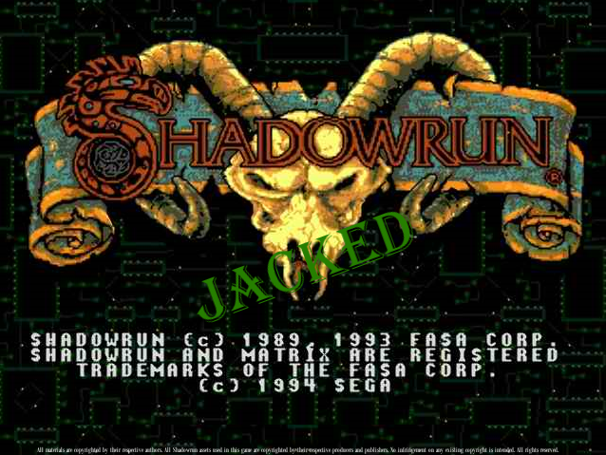

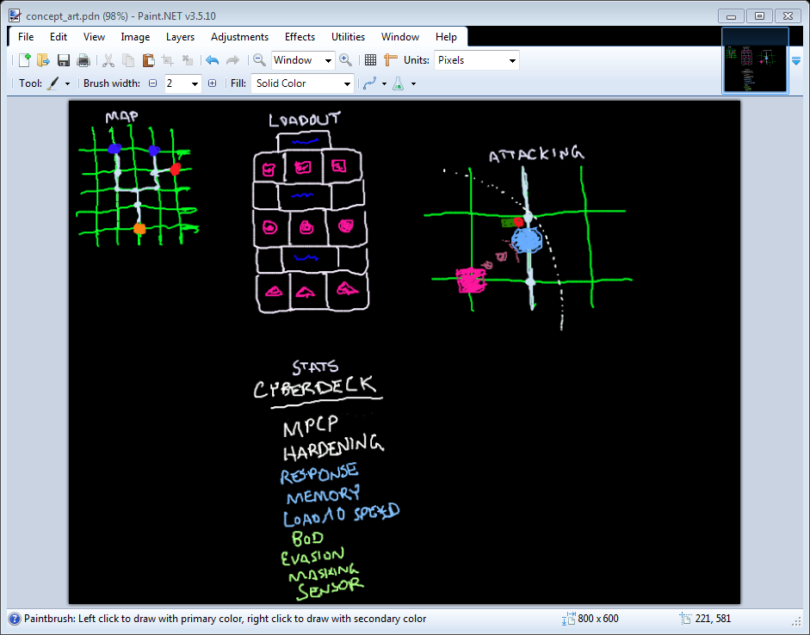



# Concept Art (Cont’d):

All materials are copyrighted by their respective authors. All Shadowrun assets used in this game are copyrighted by their respective producers and publishers.

No infringement on any existing copyright is intended. All rights reserved.

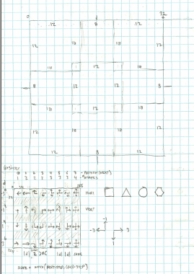



1 Line of Code:

currentY = scr_path_creation(currentY, 7, 1, currentX, 4); // Down

^= constant for the next direction

(Start Position, Number to Draw, Direction, Constant Position, Next Direction)

Below: color place holders

Right: color want to get

* Will have multiple path tile sheets for each type of “nodes” there are

# Concept Art (Cont’d):

All materials are copyrighted by their respective authors. All Shadowrun assets used in this game are copyrighted by their respective producers and publishers.

No infringement on any existing copyright is intended. All rights reserved.

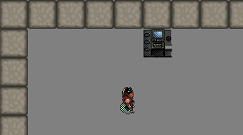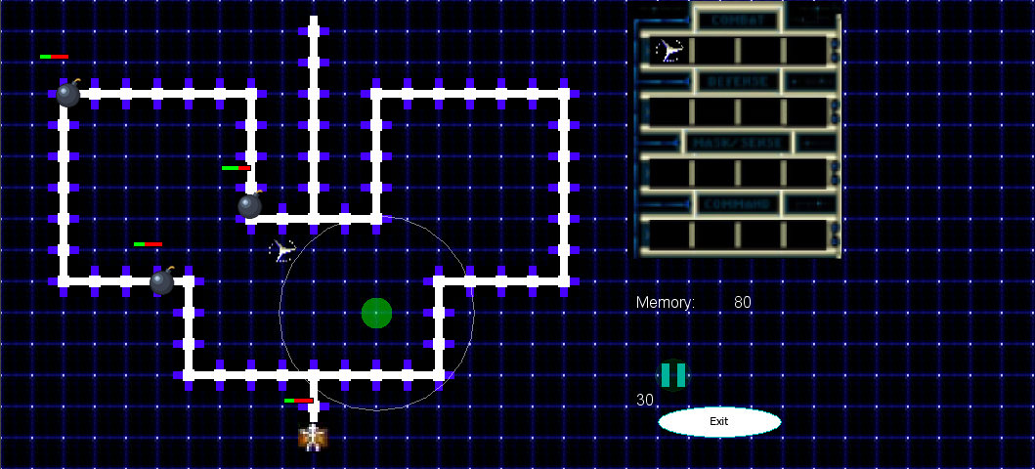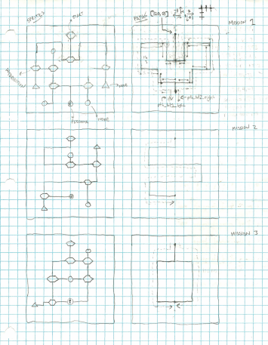

# Appendix A:

**List of objects:**

Player:

obj_persona

Game

Ctrl_game

Towers

Par_tower

Obj_tower1

Obj_tower2

Obj_tower3

Obj_tower4

Enemies

Par_ice

Obj_ice1

Obj_ice2

Obj_ice3

Obj_ice4

Menu

Btn_exit

Btn_attack

Obj_menu

Obj_next_ice

Text

Obj_log

Ctrl_splash

Room

Obj_wall

Obj_path

# Appendix B:

**List of sprites:**

Player

Spr_persona

Spr_player

Spr_cyberdeck

Towers

Spr_tower1

Spr_tower1_bullet

Spr_tower2

Spr_tower2_bullet

Spr_tower3

Spr_tower3_bullet

Spr_tower4

Spr_tower4_bullet

Menu

Spr_border

Spr_button1

Spr_tower1

Spr_tower2

Spr_tower3

Spr_tower4

Spr_menu

Misc

Spr_wall

Tiles:

Tle_menu

Tle_loadout

Tle_jacked_logo

Tle_path

Backgrounds:

Bg_grid

Bg_logo